2013 LUND SPORT-ANGLER 2000
Asking price $40,400, Reasonable offers will be considered.
530 249-1430 leave message if no answer.
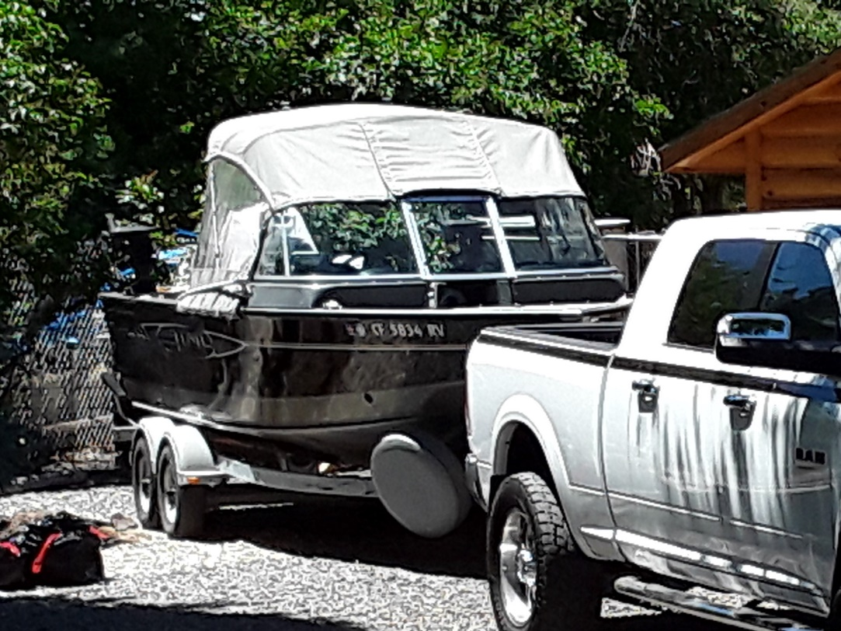

20FT Lund outfitted and ready to fish.
Full canopy with side curtains and drop curtain
Full bow to stern storage cover with poles
Adjustable snaps on boat gunnels for all covers and canopies.
Bow cover, under windshield walkthrough panel
2 electric Scotty 1101 depth-power Down Riggers with 3 balls, Extra clips/cables, mounting pads (Everything is included)
Lowrance HD 7 GPS depth/fish finder
VHF Radio
All gauges
150 4-Stroke Mercury Outboard w/trolling plate (Mechanic states less than 100 hours)
9.9 4-Stroke Mercury Trolling motor/aux steering/separate throttle
Bow live well
Sink/wash down pump/hose assembly
Anchor storage
New anchor in box/w chain & 150ft of rope, auxiliary anchor included no rope,
(hitches/balls/light plug adapters available)
Life Jackets, Rod Holders other amenities all included.
Excellent Condition
INTERIOR
Side seats with storage (2)
Captains pedestal seats (2)
3 extra pedestal chair mounts 2 in back, 1 in bow
Lockable glove box
Storage under dash & windshield
Floor storage compartment
Excellent Condition. Stored over winters covered under shelter.
TRAILER
Swing tongue tandem Lund Trailer, 4 new tires, spare, bunk guides.
